**Project Title**

**Phase 2: Project Execution and Demonstration**

**1. Project Title:**

**Next Sentence Prediction using Generative AI**

**2. Objective Recap:**

The objective of this project is to build a **Next Sentence Prediction** system using **Generative AI** models. The system takes an input sentence and generates one or more plausible next sentences based on the context, using state-of-the-art NLP models.

**3. Technologies Used:**

* Python
* HuggingFace Transformers
* Streamlit (for web interface)
* Google Colab / Jupyter Notebook
* Pre-trained GPT-2 Model

**4. Full Code Implementation:**

**Step 1: Install Required Libraries**

pip install transformers streamlit

**Step 2: Import Required Libraries**

from transformers import pipeline, set_seed

import streamlit as st

**Step 3: Load the Pretrained GPT-2 Model**

generator = pipeline('text-generation', model='gpt2')

set_seed(42)

**Step 4: Build Streamlit Interface**

st.title("Next Sentence Prediction using Generative AI")

st.write("Enter a sentence to predict the most likely next sentence.")

input_text = st.text_input("Enter your sentence here:")

if input_text:

st.subheader("Generated Sentences:")

outputs = generator(input_text, max_length=50, num_return_sequences=3)

for i, output in enumerate(outputs):

st.write(f"{i+1}. {output['generated_text']}")

**Step 5: Run the Streamlit App**

streamlit run app.py

**5. Output Screenshots:**

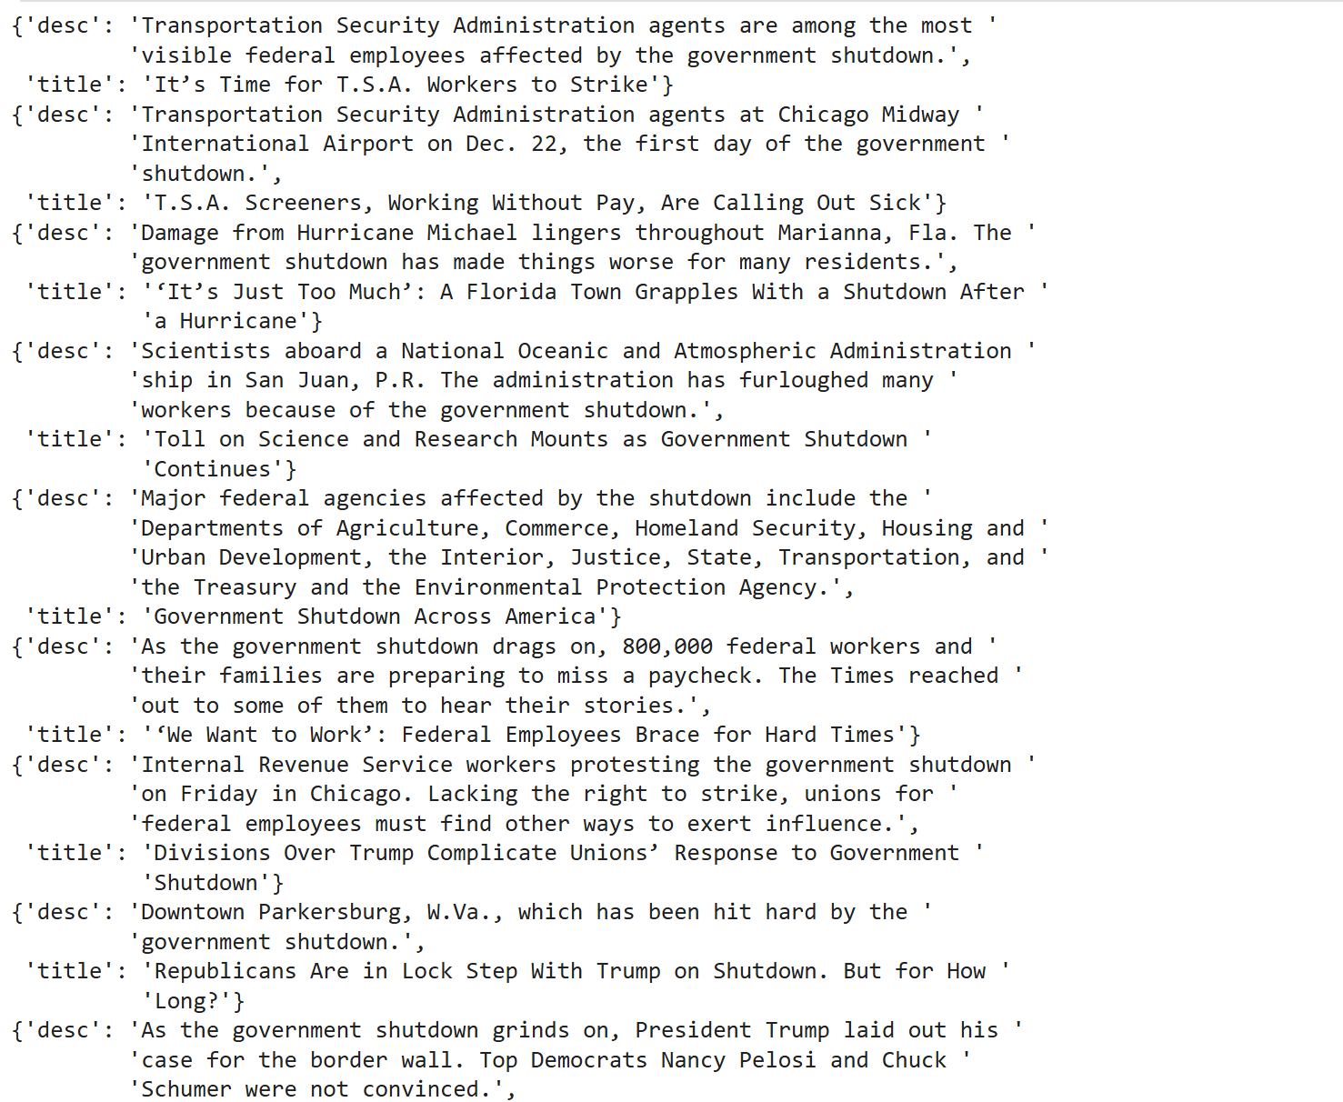

**6. Conclusion:**

This project successfully implements a **Next Sentence Prediction** system using GPT-2, demonstrating how **Generative AI** can be used for intelligent and context-aware text generation. The application showcases potential for smart writing assistance, chatbot continuity, and NLP-based innovation.

**7. References:**

* HuggingFace Transformers Documentation
* OpenAI GPT-2 Research and API
* Streamlit Documentation